**Project 7 Coin Detection with OpenCV**

Name: Aditya Vasantharao Period: 4 Date: 3/27/22

Did you name your file l071.cpp (Lower case L, then 071)? Yes

Did you use OpenCV to detect coins? Yes

Did you test your code on terminal/gnu linux in c++11? Yes

What functions/methods from OpenCV did you use?

imread()

GaussianBlur()

Canny()

Imwrite()

HoughCircles()

circle()

__________________________________________________________________________________

What functions/methods from OpenCV did you experiment with but ended up not using?

Parameters:

-F: filename

-L: lower threshold for canny edge

-U: upper threshold for canny edge

-TC: center threshold

-min_r: minimum radius of coin in image

-max_r: maximum radius of coin in image

-max_d: maximum radius of a dime in image

-max_p: maximum radius of a penny in image

-max_n: maximum radius of a nickel in image

-max_q: maximum radius of a quarter in image

-gauss_size: size of gaussian kernel to use in Gaussian Blurring

-gauss_kernel: kernel number to use in Gaussian Blurring

-max_silver_dollar: maximum radius of a silver dollar in image (if no silver dollars in image, use 0)

Run your code (the same code you submit) on the 3 images I provided (easy, medium, hard) then paste here the following:

* The initial image ( the one I provided), the imageg.jpg, imagef.jpg, coins.jpg you obtained running your code, copy paste here the content of your results.txt file your code created

1. For the easy image:

Command line including all parameter values used for this image:

./l071 -F coins1.jpg -L 30 -U 50 -TC 15 -min_r 75 -max_r 140 -max_d 81 -max_p 94 -max_n 109 -max_q 133 -gauss_size 21 -gauss_kernel 6

Initial image:

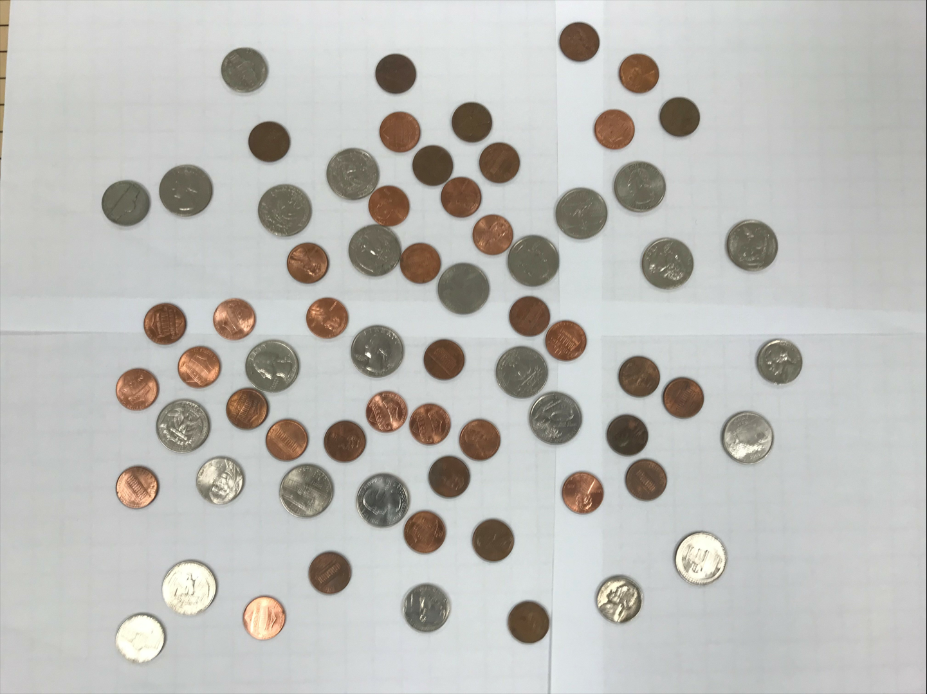

imageg,jpg:

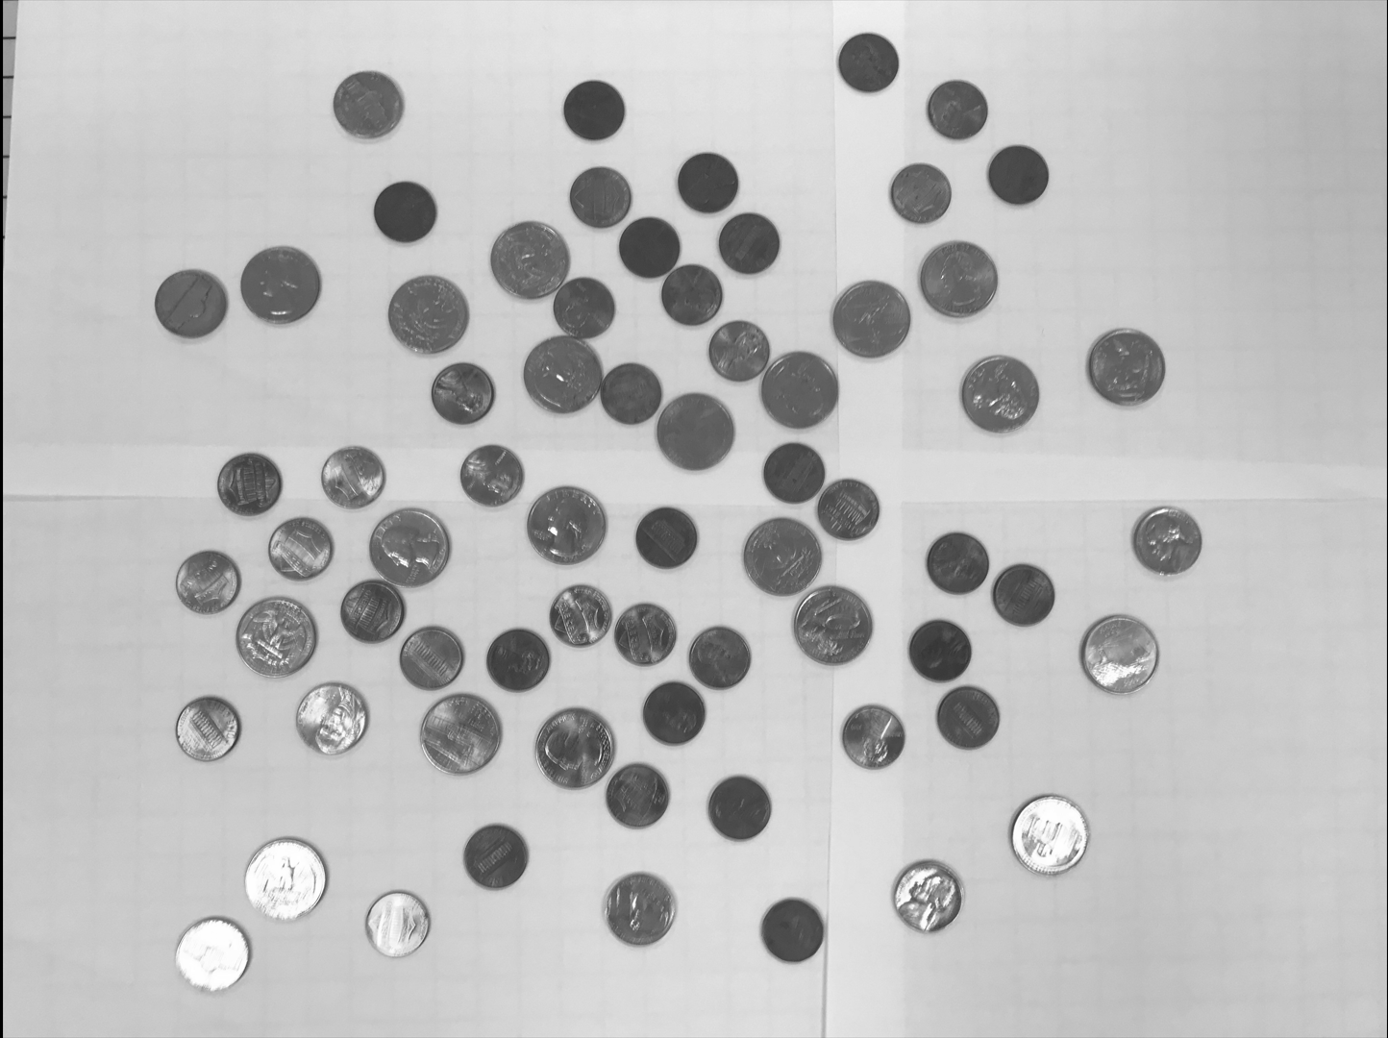

imagef.jpg:

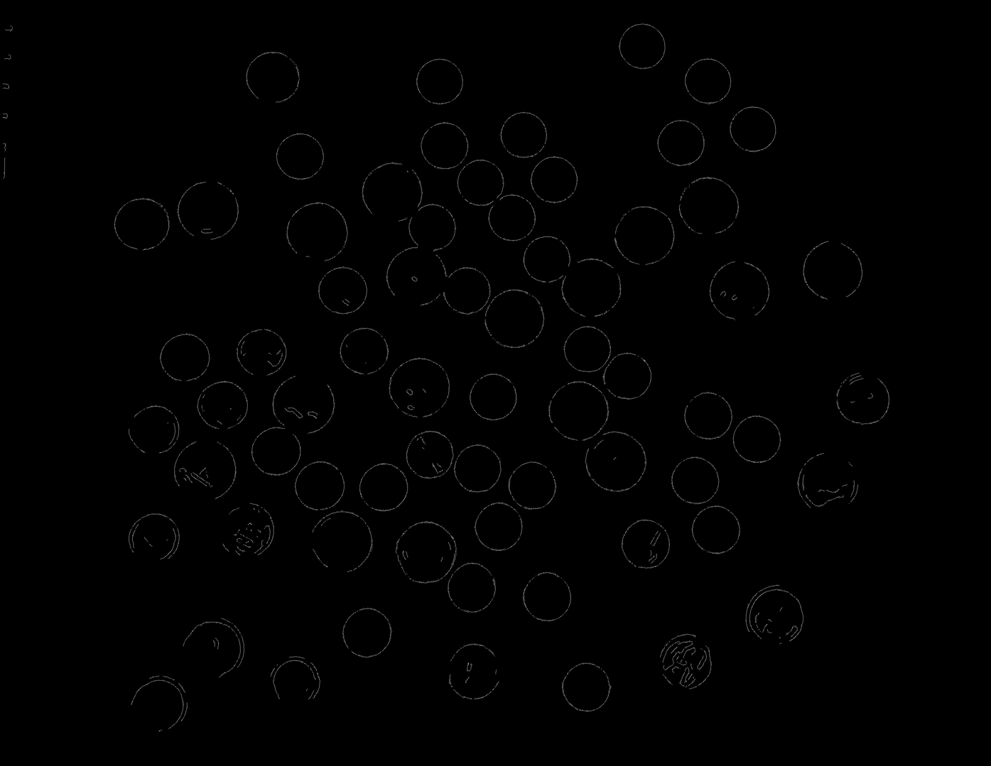

coins.jpg:

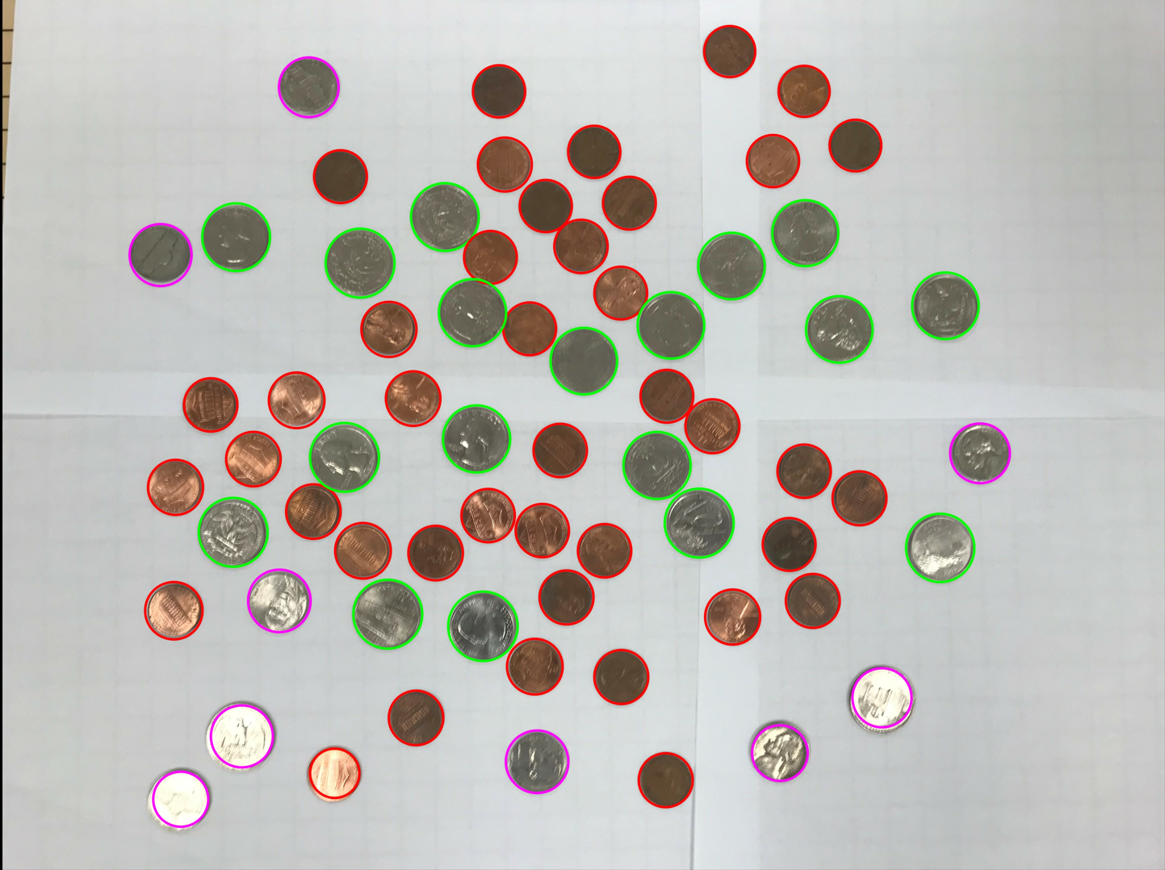

Content of results.txt:

41 Pennies

9 Nickels

0 Dimes

18 Quarters

0 Silver Dollars

Total sum: $5.36

1. For the medium image:

Command line including all parameter values used for this image:

./l071 -F coins2.jpg -L 30 -U 51 -TC 19 -min_r 70 -max_r 140 -max_d 75 -max_p 94 -max_n 104 -max_q 133 -gauss_size 21 -gauss_kernel 6

Initial image:

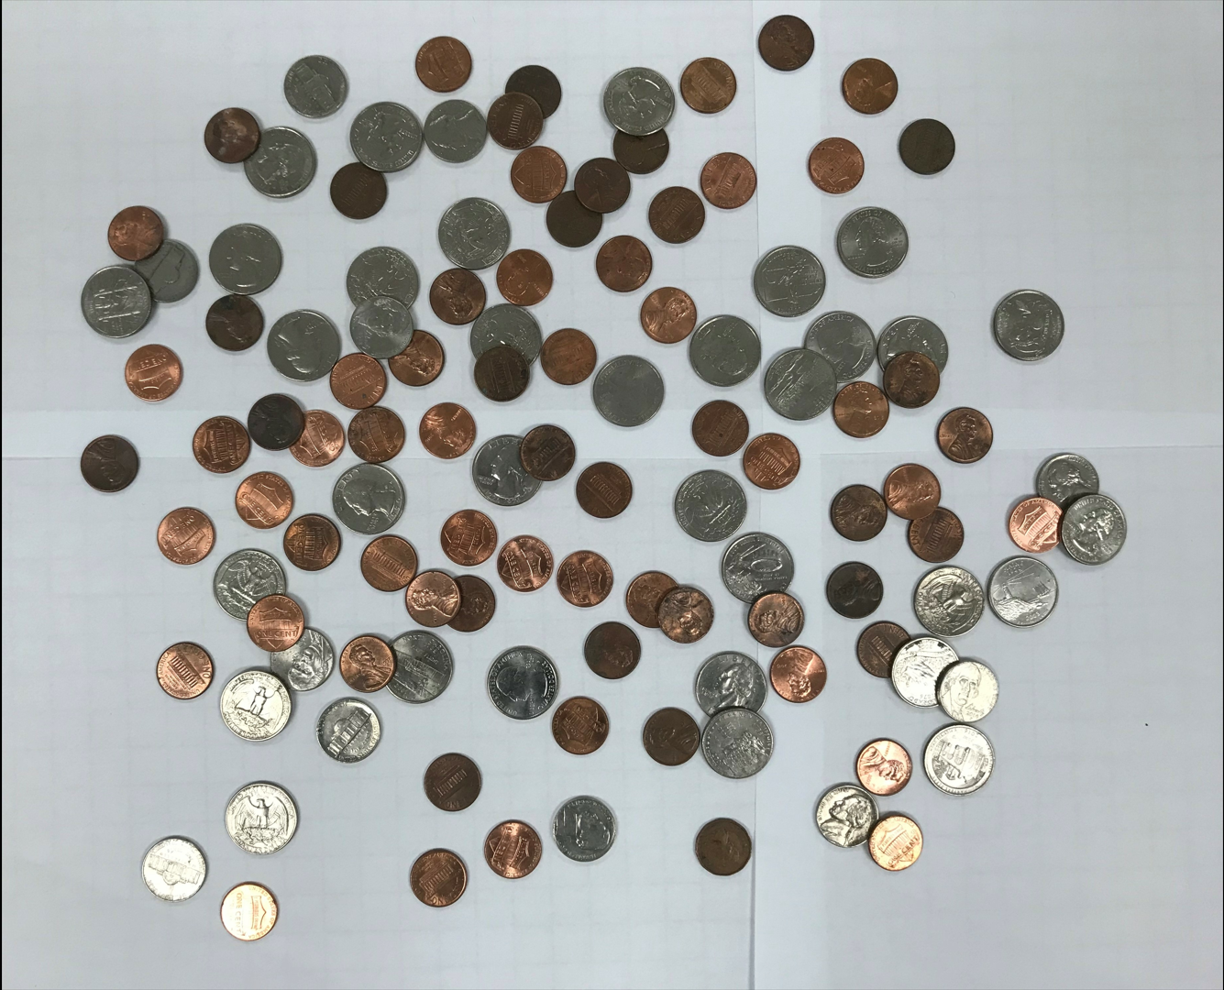

imageg,jpg:

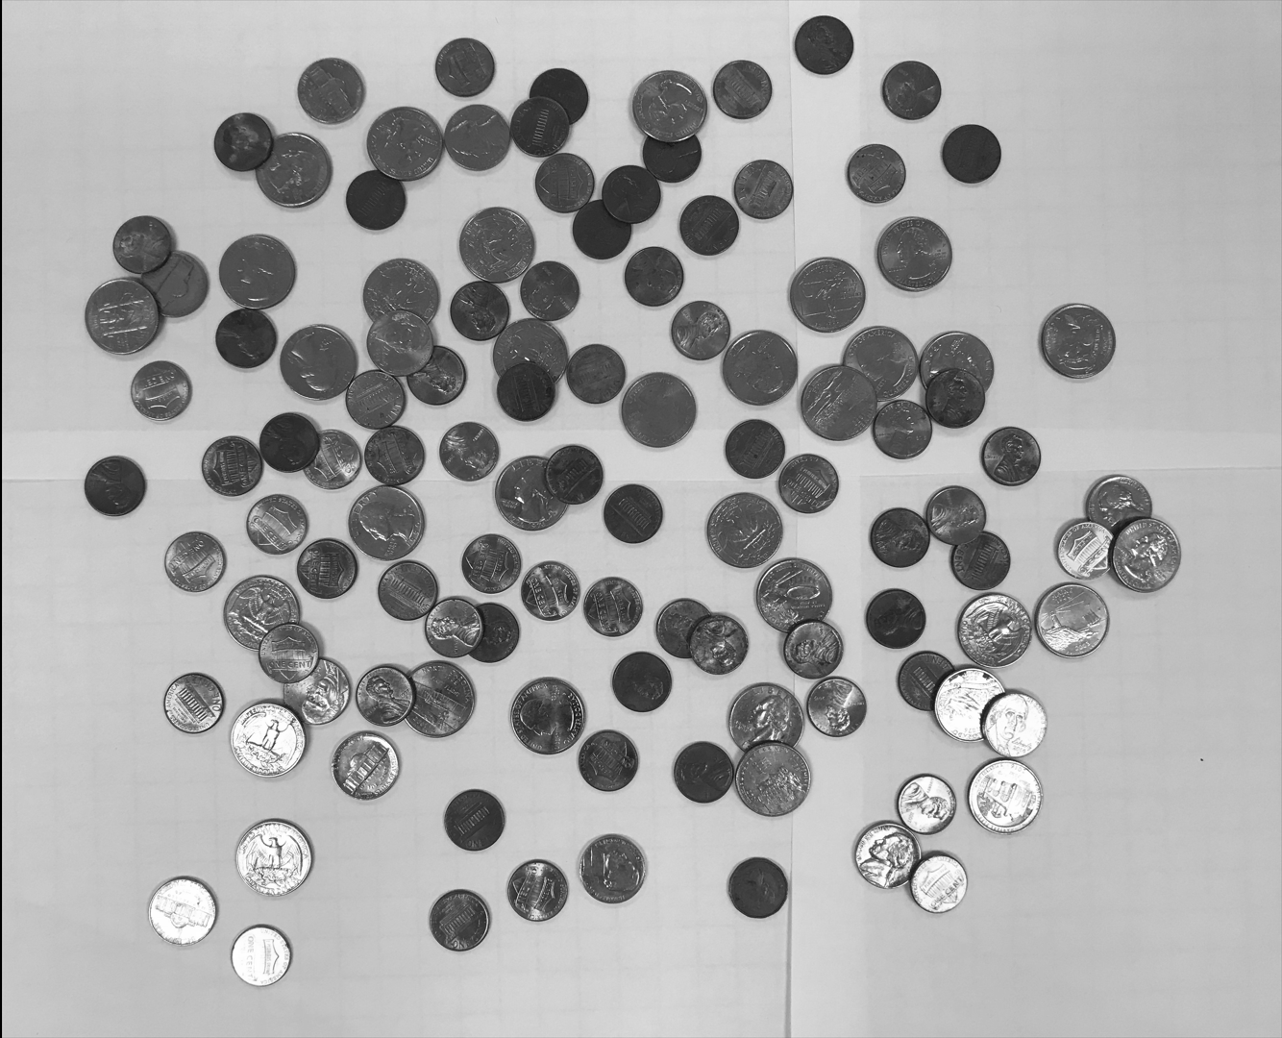

imagef.jpg:

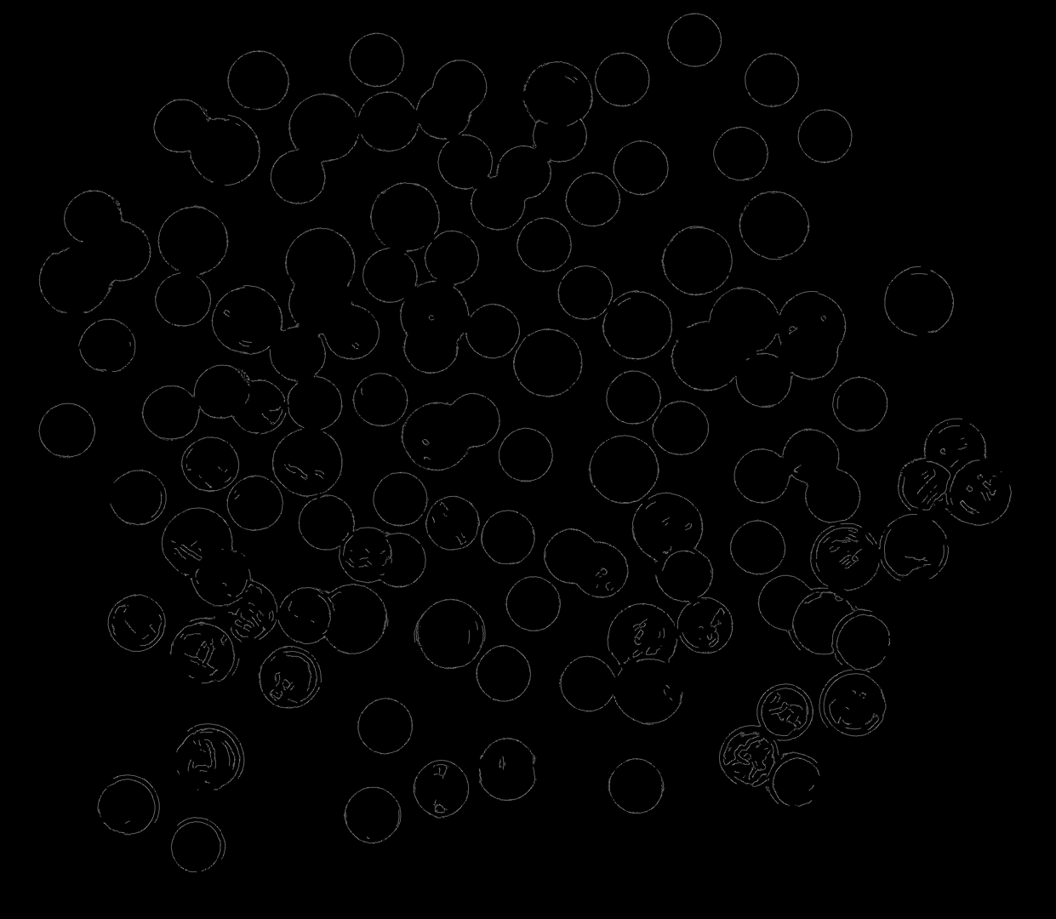

coins.jpg:

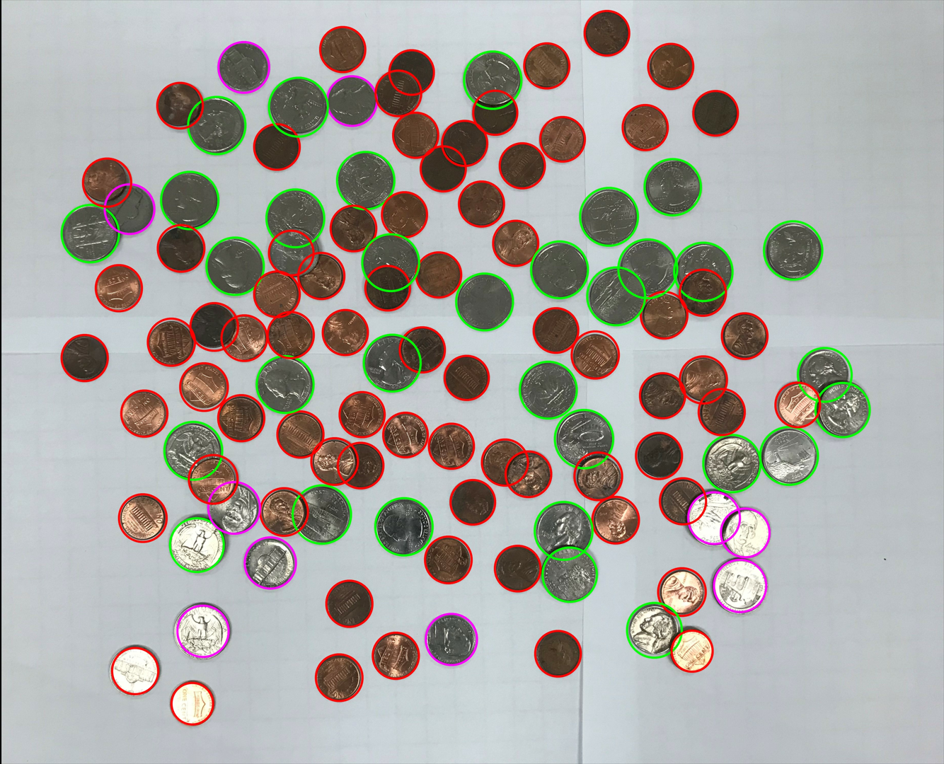

Content of results.txt:

74 Pennies

10 Nickels

0 Dimes

32 Quarters

0 Silver Dollars

Total sum: $9.24

1. For the hard image:

Command line including all parameter values used for this image:

./l071 -F coins3.jpg -L 10 -U 31 -TC 15 -min_r 56 -max_r 106 -max_d 86 -max_p 94 -max_n 106 -max_q 133 -gauss_size 33 -gauss_kernel 8 -max_silver_dollar 175

Initial image:

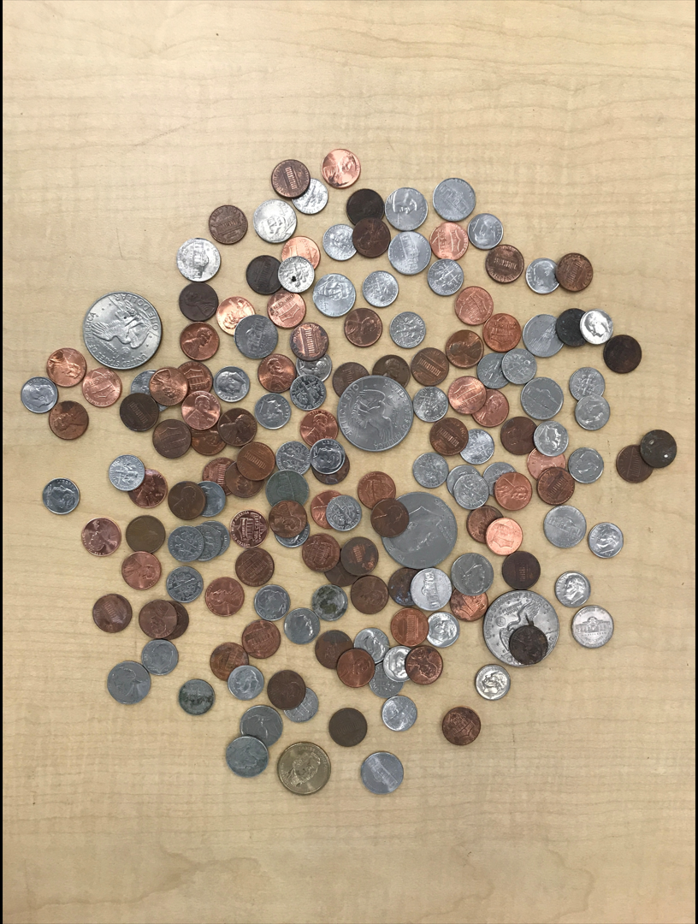

imageg,jpg:

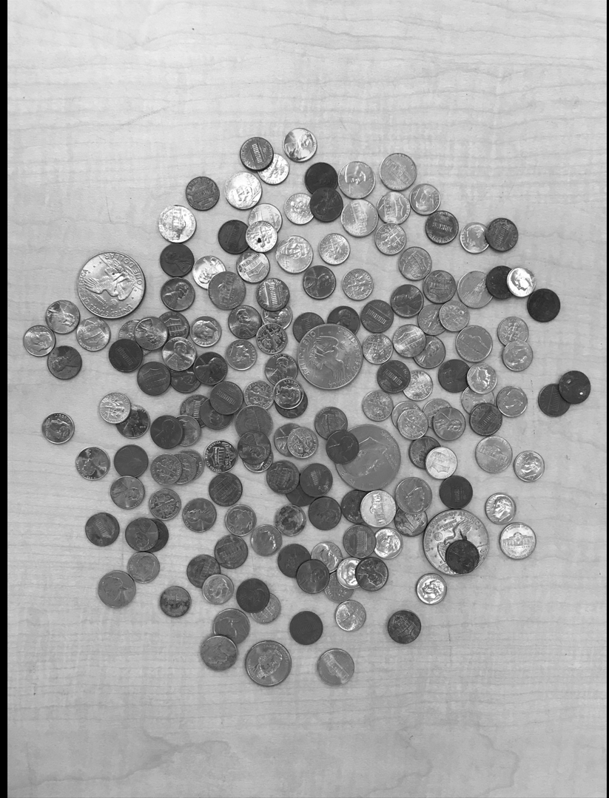

imagef.jpg:

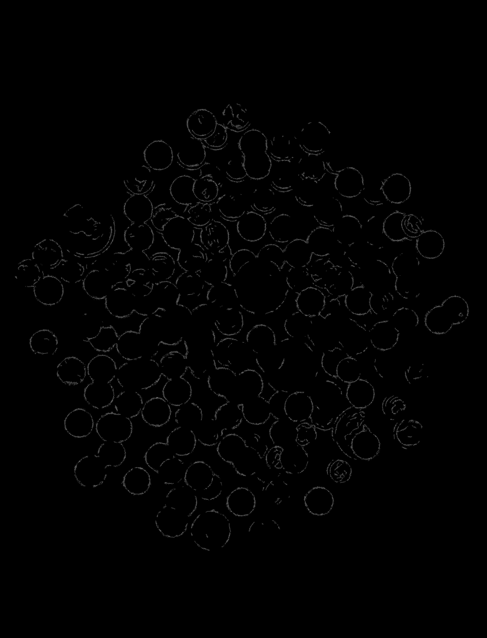

coins.jpg:

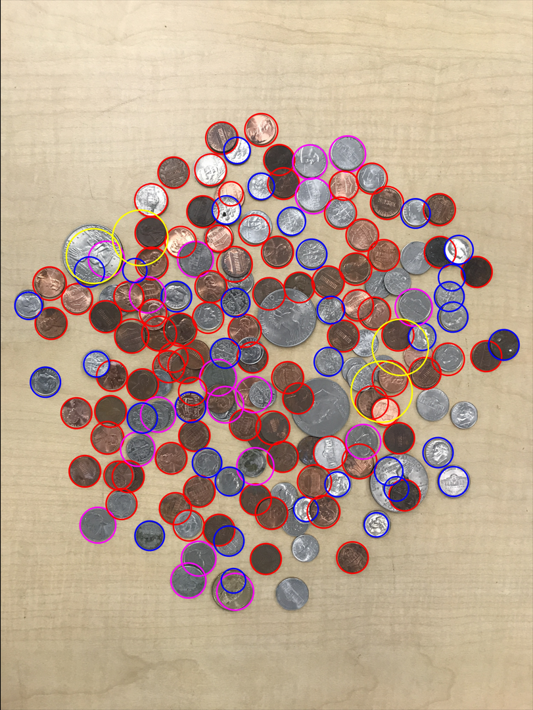

Content of results.txt:

74 Pennies

10 Nickels

0 Dimes

32 Quarters

0 Silver Dollars

Total sum: $9.24